SECTION 1. PRODUCT AND COMPANY INDENTIFICATION
Product Name: | BAMBOO DREAMS CANDLE
Product Code: | SCE822907
Customer Material:
Product Use Description: | Fragrance Compund
Company: | VAPORO Fragrances & Specialties NJ CORP  200 Clifton Blvd – Suite 2  Clifton, NJ 07011

SECTION 2. HAZARDS IDENTIFICATION
GHS-Classification
Skin irritation, Category 2
Skin sensitisation, Category 1
GHS-Labeling
Symbol(s): | 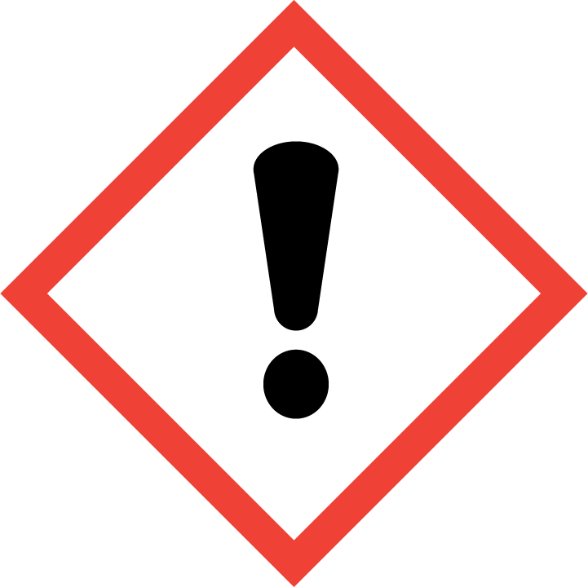
Signal word: | WARNING
Hazard statements: | H315: Causes skin irritation.  H317: May cause an allergic skin reaction.
Precautionary statements: | P261: Avoid breathing mist or vapours.  P280: Wear protective gloves.  P302 + P352: IF ON SKIN: Wash with plenty of soap and water.  P333 + P313: If skin irritation or rash occurs: Get medical advice/ attention.  P501: Dispose of contents/ container to an approved waste disposal plant.
Carcinogenicity:
No component of this product present at levels greater than or equal to 0.1% is identified as probable, possible or confirmed human carcinogen by IARC.
No component of this product present at levels greater than or equal to 0.1% is on OSHA’s list of regulated carcinogens.
No component of this product present at levels greater than or equal to 0.1% is identified as a known or anticipated carcinogen by NTP.

SECTION 3. COMPOSITION/INFORMATION ON INGREDIENTS
Chemical nature: | Fragrance for consumer product
Fragrance Compound: A multi component mixture of fragrance ingredients. The specific chemical identities of the ingredients not listed herein are considered by VAPORO to be Trade Secrets and are withheld in accordance with the provisions of 1910.1200 of Title29 of the U.S. Code of Federal Regulations.

SECTION 4. FIRST AID MEASURES
First aid procedures
Inhalation: | Remove from exposure site to fresh air and keep at rest. If victim is unconscious, remove foreign bodies from the mouth. If victim has stopped breathing, give artificial respiration. Obtain medical advice.
Skin contact: | Remove contaminated clothes. Wash thoroughly with water (and soap). Contact physician if symptoms persist.
Eye contact: | Flush immediately with water for at least 15 minutes. Contact  physician if symptoms persist
Ingestion: | Rinse mouth with water and obtain medical advice.
Notes to physician
Risks: | Causes skin irritation.  May cause an allergic skin reaction.

SECTION 5. FIRE-FIGHTING MEASURES
Flammable properties
Flash point: | 275.00 °F (135.00 °C)
Fire fighting
Suitable extinguishing media: | Use water spray, dry chemical, carbon dioxide or appropriate foam.
Protective equipment and precautions for firefighters
Special protective equipment for fire-fighters: | Wear NIOSH approved self-contained breathing apparatus and full protective clothing when fighting fires involving chemicals. Use water spray to cool containers exposed to fire.

SECTION 6. ACCIDENTAL RELEASE MEASURES
Personal precautions: | Avoid inhalation and contact with skin and eyes. A self-contained breathing apparatus is recommended in case of a major spill.
Environmental precautions: | Keep away from drains, surface- and groundwater and soil.
Methods for containment / Methods for cleaning up: | Clean up spillage promptly. Remove ignition sources. Provide adequate ventilation. Avoid excessive inhalation of vapours. Gross spillages should be contained by use of sand or inert powder and disposed of according to the local regulations.

SECTION 7. HANDLING AND STORAGE
Handling: | Avoid excessive inhalation of concentrated vapors. Follow good manufacturing practices for housekeeping and personal hygiene. Wash any exposed skin immediately after any chemical contact, before breaks and meals, and at the end of each work period. Contaminated clothing and shoes should be thoroughly cleaned  before re-use.  If appropriate, procedures used during the handling of this material should also be used when cleaning equipment or removing residual chemicals from tanks or other containers, especially when steam or hot water is used, as this may increase vapor concentrations in the workplace air. Where chemicals are openly handled, access should be restricted to properly trained employees. Keep all heated processes at the lowest necessary temperature in order to minimize emissions of volatile chemicals into the air.
Advice on protection againt fire and explosion: | Keep away from ignition sources and naked flame.
Requirements for storage areas and containers: | Store in a cool, dry, ventilated area away from heat sources. Keep  containers upright and tightly closed when not in use.

SECTION 8. EXPOSURE CONTROLS/PERSONAL PROTECTION
Ingredients with workplace control parameters
Engineering measures: | Where feasible, isolate mixing rooms and other areas where this material is used or openly handled. Maintain these areas under negative air pressure relative to the rest of the plant. Where feasible, use closed systems to transfer and process this material.
Personal protective equipment
Eye protection: | Use tight-fitting goggles, face shield or safety glasses with side  shields if eye contact might occur.
Hand protection: | Avoid skin contact. Use chemically resistant gloves.
Skin and body protection: | Choose body protection in relation to its type, to the concentration and amount of dangerous substances, and to the specific work-place.  Personal protection through wearing a tightly closed chemical protection suit and a self-contained breathing apparatus.
Respiratory protection: | Use local exhaust ventilation around open tanks and other open sources of potential exposures in order to avoid excessive inhalation, including places where this material is openly weighed or measured. In addition, use general dilution ventilation of the work area to eliminate or reduce possible worker exposures. No respiratory protection is required during normal operations in a workplace where engineering controls such as adequate ventilation, etc. are sufficient.  If engineering controls and safe work practices are not sufficient, an approved, properly fitted respirator with organic vapor cartridges or canisters and particulate filters should be used:  a)while engineering controls and appropriate safe work practices and/or procedures are being implemented; or  b)during short term maintenance procedures when engineering controls are not in normal operation or are not sufficient; or  c)if normal operational workplace vapor concentration in the air is increased due to heat ;  d)during emergencies; or  e)if engineering controls and operational practices are not sufficient to reduce airborne concentrations below an established occupational exposure limit.
Hygiene measures: | To the extent deemed appropriate, implement pre-placement and regularly scheduled ascertainment of symptoms and spirometry testing of lung function for workers who are regularly exposed to this material.  To the extent deemed appropriate, use an experienced air sampling expert to identify and measure volatile chemicals that could be present in the workplace air to determine potential exposures and to ensure the continuing effectiveness of engineering controls and operational practices to minimize exposure.
Protective measures: | In December 2003, the National Institute for Occupational Safety and Health ("NIOSH") published an Alert on preventing lung disease in workers who use or make flavorings [NIOSH Publication Number 2004-110].  In August 2004, the United States Flavor and Extract Manufacturers Association (FEMA) issued a report entitled "Respiratory Safety in the Flavor Manufacturing Workplace".  Both of these reports provide recommendations for reducing employee exposure and for medical surveillance in the workplace. The recommendations in these reports are generally applicable to the  use of any chemical in the workplace and you are strongly urged to review both of these reports.  The report published by FEMA also contains a list of "high priority" chemicals. If any of these chemicals are present in this product at a concentration >= 1.0% due to an intentional addition by VAPORO, the chemical(s) will be identified in this safety data sheet.

SECTION 9. PHYSICAL AND CHEMICAL PROPERTIES
Appearance
Physical state: | Liquid
Appearance: | Clear Liquid
Odor: | Conforms to standard
Safety Data
Flash point: | 275.00 °F (135.00 °C)

SECTION 10. STABILITY AND REACTIVITY
Conditions to avoid: | Remarks: Direct sources of heat.
Chemical stability: | Remarks: Presents no significant reactivity hazard, by itself or in contact with water. Avoid contact with strong acids, alkali or oxidizing agents.
Hazardous decomposition products: | Note: Carbon monoxide and unidentified organic compounds may  be formed during combustion.

SECTION 11. TOXICOLOGICAL INFORMATION
Toxicological information: | There is no data available for this product. The health hazards are assessed based on the ingredients in this preparation and their concentrations.

SECTION 12. ECOLOGICAL INFORMATION
Ecological information
Additional ecological information: | Avoid contamination of soil, ground and surface water.

SECTION 13. DISPOSAL CONSIDERATIONS
Contaminated packaging: | Place material into sealed containers and dispose of in accordance with local, state and federal regulations.

SECTION 14. TRANSPORT INFORMATION
DOT | Not dangerous goods
IATA
UN number: | 3082
Description of the goods: | ENVIRONMENTALLY HAZARDOUS SUBSTANCE, LIQUID, N.O.S. (Hexamethylindanopyran)
Class: | 9
Packing group: | III
ICAO-Labels: | 9
IMDG
UN number: | 3082
Description of the goods: | ENVIRONMENTALLY HAZARDOUS SUBSTANCE, LIQUID, N.O.S. (Hexamethylindanopyran)
Class: | 9
Packing group: | III
IMDG-Labels: | 9
EmSNumber 1 | F-A
EmSNumber 2 | S-F
Marine pollutant | Yes (Hexamethylindanopyran)
Other Information
Shipment by ground under DOT is non-regulated; however it may be shipped per the applicable hazard classification to facilitate multi-modal
transport involving ICAO (IATA) or IMO.

SECTION 15. REGULATORY INFORMATION
SARA 313 Components :  SARA 311/312 Hazards : | HEXAMETHYLINDANOPYRAN 1222-05-5  Respiratory or skin sensitisation  Skin corrosion or irritation
Reportable Quantity:
HMIS Classification
Health Hazard: | 2
Chronic Health Hazard: | *
Flammability: | 1
Physical and chemical hazards: | 0

SECTION 16. OTHER INFORMATION
Further information
The information in this MSDS was obtained from current and reliable sources. However, the data is provided without any warrant, expressed or implied, regarding its correctness or accuracy. Since the use, handling, storage and disposal of this product are beyond VAPORO control, it is the responsibility of the user both to determine safe conditions for the use of this product and to assume liability of loss, damage, or expense arising out of the product's improper use. No warranty expressed or implied regarding the product described herein shall be created by or inferred from any statement or omission in this MSDS. Various Federal, State or Provincial agencies may have specific regulations concerning the transportation, handling, storage, use, or disposal of this product which may not be reflected in this MSDS. The user should review these regulations to ensure full
compliance

